Icon Library Usage for CS Web Applications

In order to keep a centralized location for icon library graphics, and to avoid having the same image used multiple times with different names, the following will be used for storing and deploying the icon library.

Files should be added to Perforce at this location: //depot/Informatics/Team/.net/ChemOfficeEnterprise/Framework/CambridgeSoft/CommonResources/IconLibrary

This will be added to the COECommonResources virtual directory from the installer. For development purposes you can change the location of this directory to your CommonResources location on your hard drive that perforce uses.

We will keep the directory structure that the IconLibrary uses except for one change. (ie we will be keeping the collections separate and continue use of the names)

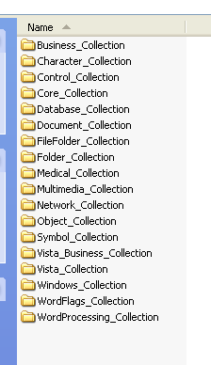

The changes will be made at the size level. Currently the Icon Library has inconstancy in the folder names for sizes. For example sometimes the directory is called 16 and other times it is called 16x16.

Ex. C:\grafile_library\Business_Collection\Aqua\PNG\16x16
C:\grafile_library\Core_Collection\Core_Aqua\PNG\16

We are going to use a small, medium, large, xlarge convention.
xsmall | 16x16
small | 24x24
medium | 32x32
large | 48x48
xlarge | 64x 64 | If needed
xxlarge | 128x128 | If needed

Ex. C:\grafile_library\Business_Collection\Aqua\PNG\xsmall\About.png
C:\grafile_library\Business_Collection\Aqua\PNG\small\About.png

In addition to consistency this means that if we were to change libraries and the sizes did not match the 16, 24, 32 sizes (etc), we could continue to use the small, medium, and large naming convention.

Sample Code Usage
<img src=”/COECommonResources/IconLibrary/Business_Collection/Aqua/PNG/small/About.png”>

Utility functions for choosing the size (xsmall, small, medium, large, xlarge) based on either configuration settings or user settings can be added as needed.

For example home page usage:
//depot/Informatics/Team/.net/ChemOfficeEnterprise/Framework/CambridgeSoft/Documents/Design/coehomesettings.doc

